Customer Analysis for Sun Country Airlines

BANA 200A Group Project Report

Team 2A- Ruicheng Li, Lalitha Priya Bhupalam, Abhinav Samavedula, Chun Hui Tsai, Hilary Nguyen

### Introduction

In an increasingly competitive airline industry, Sun Country Airlines stands out as a company with its own advantages and opportunities in this industry. This report aims to provide actionable recommendations for customer behavior by segmenting Sun Country’s customer base into distinct clusters. Using K-mean clustering, we identified three distinct customer segments, each with its own characteristics. Our analysis offers targeted marketing strategies for each segment and recommendations for enhancing long-term strategy for the company. The objective is to enable Sun Country Airlines to become a more data-driven and customer-oriented organization.

### Data Analysis

**Seasonality:**

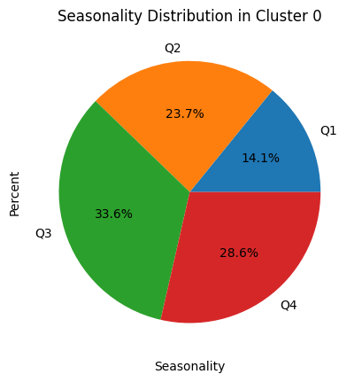

Cluster 0 has its lowest activity in Q1 but picks up in Q3 and Q4 .This segment may enjoy traveling during the summer vacation and winter.

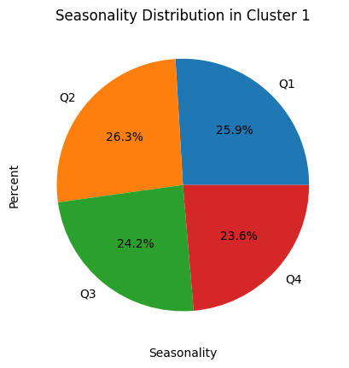

Cluster 1 shows an even distribution of travel across all four quarters. This segment is not significantly influenced by seasonality and represents a stable customer base that Sun Country can rely on year-round.

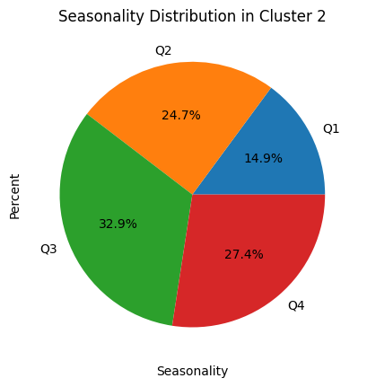

Cluster 2 shows more activity in the Q3. So these may be people who love traveling in summer and fall.

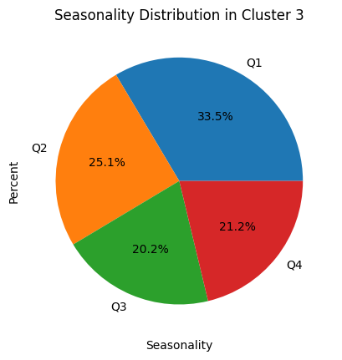

Cluster 3 shows a significant spike in Q1, dropping to its lowest in Q3. This segment consists of people traveling during spring break and Easter holiday.

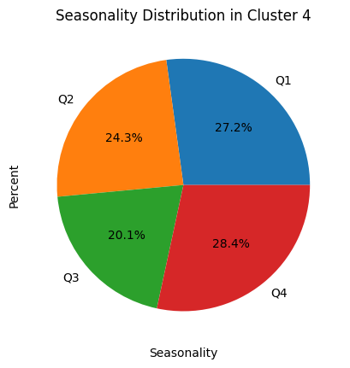

Cluster 4 shows a significant spike in Q4. This segment likely consists of customers looking to escape the winter cold, making them prime targets for winter vacation promotions. And people traveling to be with families during holidays.

**Age group:**

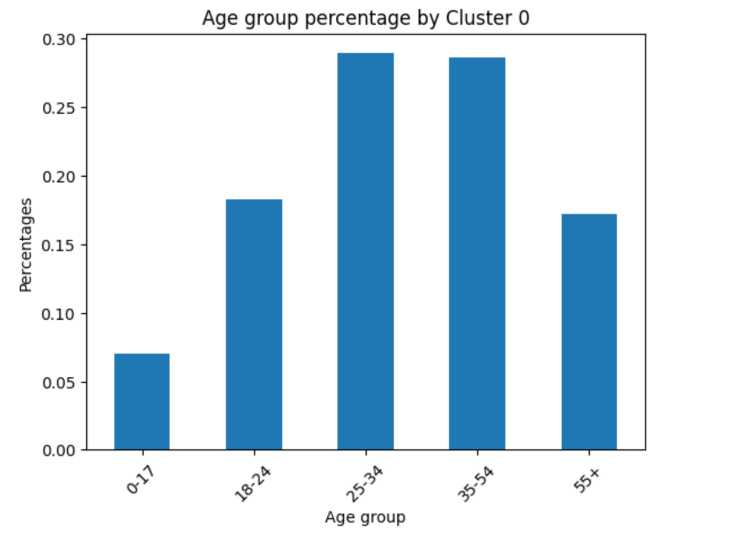

Cluster 0 has maximum passengers in the age group 25-34.

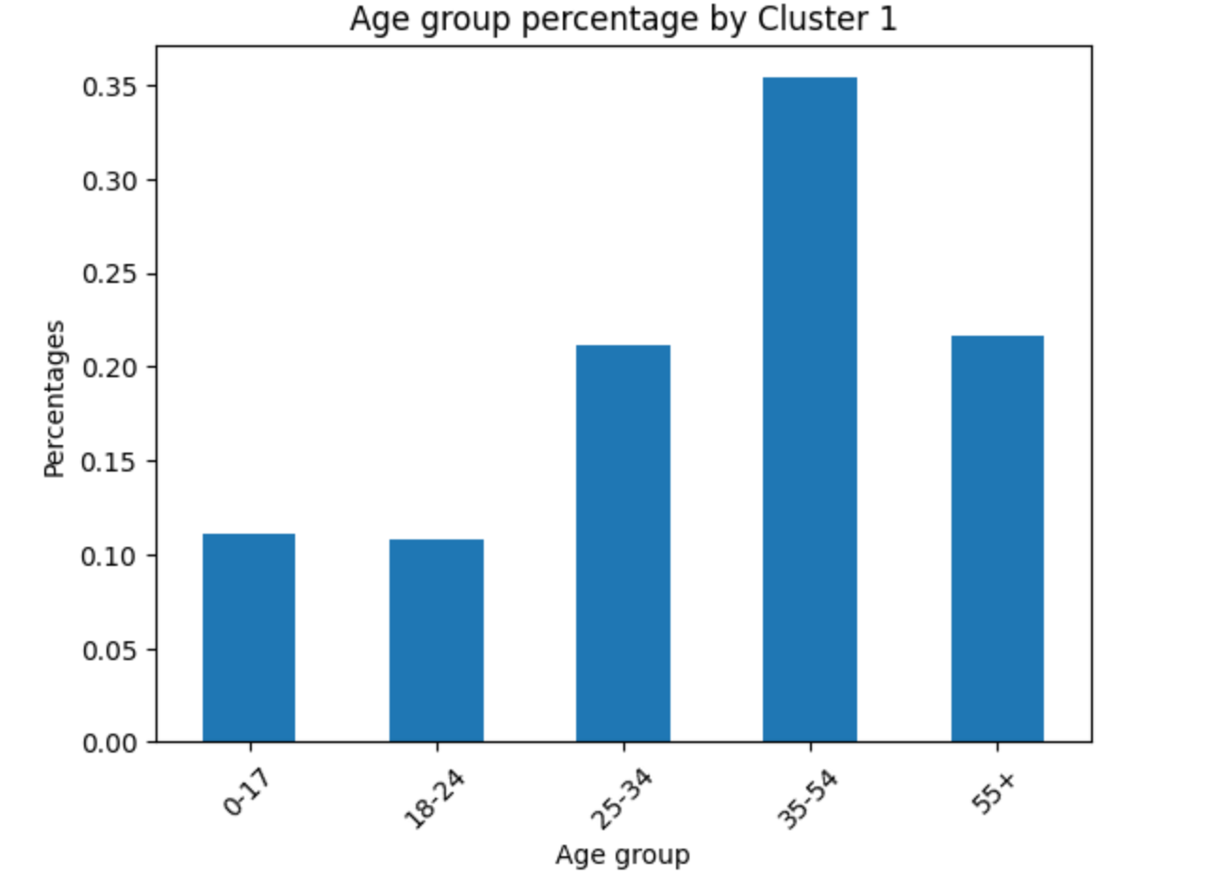

Cluster 1 has maximum passengers in the 35-54 age group.

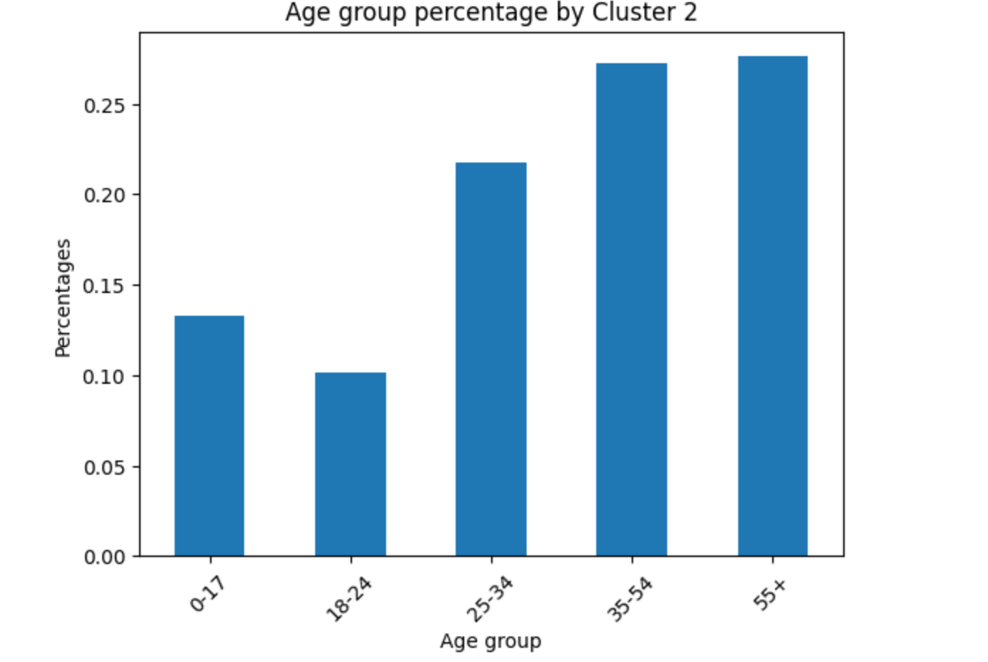

Cluster 2 has maximum passengers in the age groups 55+ and closely matching 35-54.

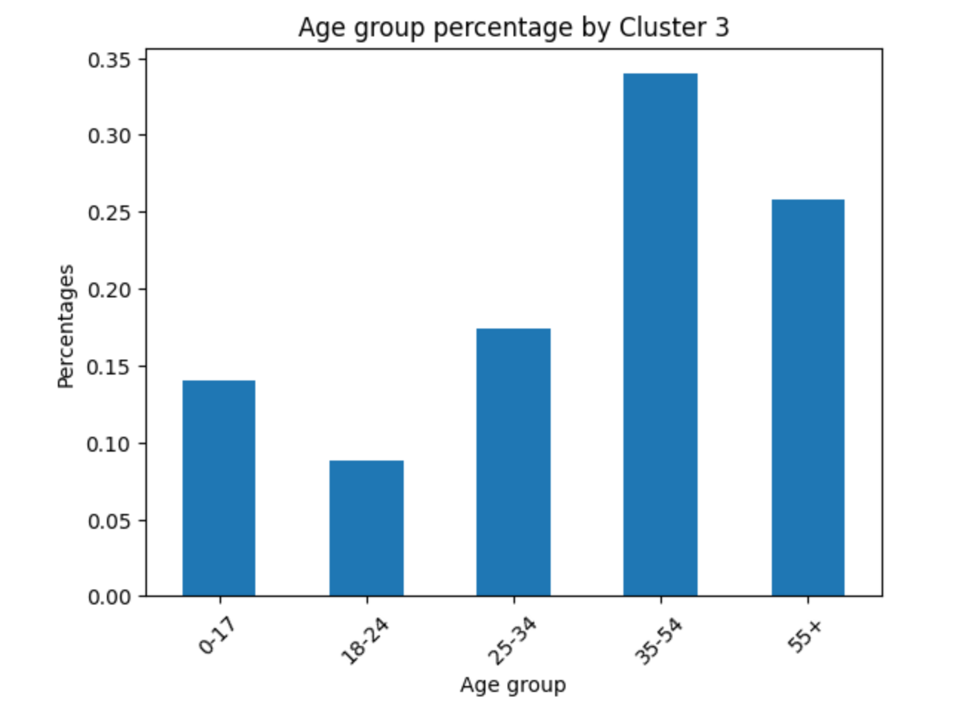

Cluster 3 also has maximum passengers in the 35-54 age group. But a unique characteristic of this cluster is that it has more passengers in the age 0-17 than any other cluster.

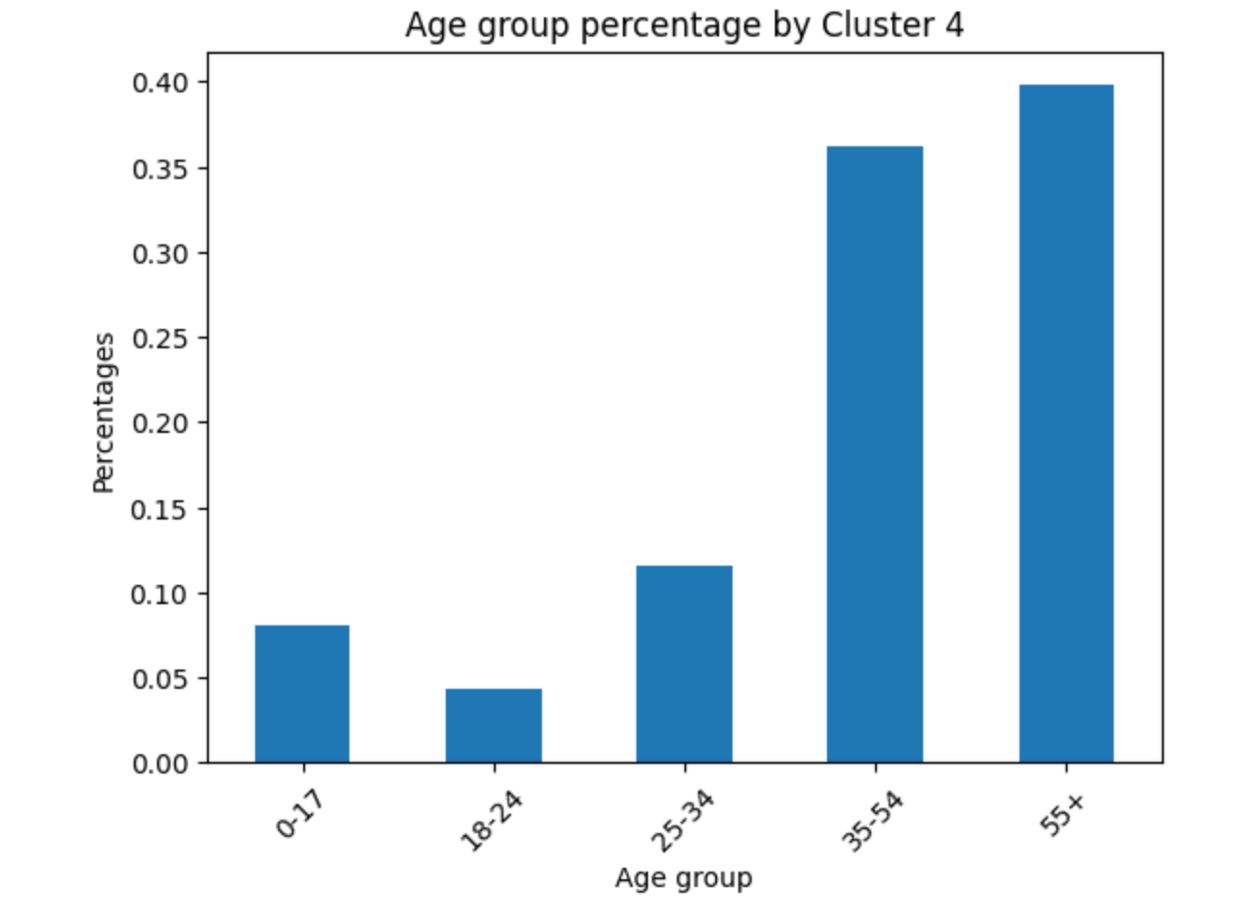

Cluster 4 has maximum passengers in the 55+ age group.

Ufly membership status:

Cluster 0, 1, and 3, are composed of more than 95% of non-Ufly customers.

Cluster 2 has 1/ 3 of members and 2/3 of non-Ufly members.

Cluster 4 is the major membership group, with 99% standard status and 1% elite status.

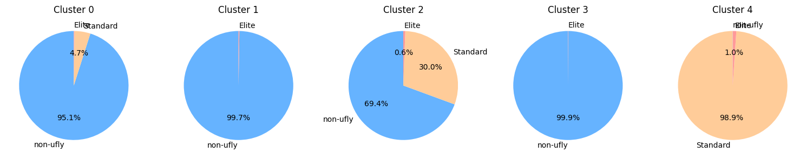



### **Case Questions: Our findings and Insights**

**Based on your analysis, how many different customer segments (i.e., clusters of similar customers) are there? What are the key characteristics of each segment? Can you come up with descriptive titles for the segments?**

Cluster 0: The Young, Budget Summer Vacationers

Cluster 0 shows a significant spike in Q3 (July, August, September) with about 33% of travelers, dropping to its lowest in Q1 (January, February, March) with about 14%. This segment likely consists of customers looking to get out and make the most of the summer months, making them prime targets for summer vacation promotions. Most passengers are in the age group 25-34. And most of them don’t have a Ufly membership.

Cluster 1: The Working All-season Travelers

Cluster 1 shows a pretty even distribution of travel across all four quarters. This segment is not significantly influenced by seasonality and represents a stable customer base that Sun Country can rely on year-round. This group consists mainly of adults from the ages of 35-54 without Ufly memberships. These adults most likely travel inconsistently throughout the year without any seasonal boundary or seasonal preference.

Cluster 2: The Family Middle Class Dual Vacationers (Two Seasons)

Cluster 2 shows a significant spike in Q3 (July, August, September) with about 33% of travelers with close activity in Q4 (October, November, December) with about 27% of traveling. This segment consists mostly of customers ages 55+ and close behind is a group of 35-54 year olds looking to travel during the Summer and Winter season. ⅓ of this cluster are Ufly members and ⅔ of this cluster are not members.

Cluster 3: The Short Family Budget Spring Vacationers

Cluster 3 shows a greater percentage of travelers in Q1 (January, February, March) of all seasons. With customers mostly at 35-54 year olds with the highest percentage of 0-17 year olds out of all the clusters, we can assume these are customers traveling with children for Easter Holiday or school spring breaks without a Ufly membership.

Cluster 4: The Old, Comfort seeking, Winter Escapists

Cluster 4 has its highest activity in Q4 with a percentage of 18.4% of Cluster 4 travelers traveling in October, November, and December months. This segment likely consists of customers ages 55 and up looking to escape the winter cold. 99% of these customers are Ufly members, meaning they consistently fly with Sun Country Airlines annually during the Winter Months.

**What advice would you offer the executives of Sun Country Airlines (Warnken and Vaughan), based on your segmentation analysis, so they can better achieve their business objectives?**

Cluster 0: The Summer Vacationers

Since this segment travels the most in the Summer months and is younger than the rest of the segments, they should receive promotions for summer destinations. Sun Country airlines can come up with catchy one liners to make a pun with their name since it has Sun in it. Since most of them are non-Ufly members, we see that they are looking for budget travel and don’t care about comfort. So providing discounts for the summer destinations if they book in a group would incentivize this segment to make more bookings and increase the profits earned during this time.

Cluster 1: The Working All-season Travelers

Since this segment travels all year round, they might be traveling for work, business, full time travelers and influencers etc. Sun Country Airlines must promote the standard membership because this group travels more than the average person. Since they are working professionals the airlines can provide cheaper early morning and late night flights to this group of people if they get the membership. We recommend sending out a promotional email to the most frequent travelers who have not already signed up for standard Ufly so they can earn rewards for flying frequently with the airline.

Cluster 2:

Since there are many seniors in Cluster 2, we recommend increasing accessibility and accommodation, such as baggage, boarding, and agent assistance with priority boarding, upgrading, and seating selection for the customers who get the standard membership.. Also, promotion for seniors should start at an earlier time for summer and winter travels. Summer and winter travel promotion should consist of collaboration with travel operators or companies by providing in flight promotions for the travel companies. This is effective because seniors usually are not good with technology and prefer assistance to do booking tasks.

Cluster 3:

We noticed an increase in the 0-17 age group in this cluster compared to the others, so we expect these to be customers who are light travelers, with younger kids, wanting to avoid the rush of peak vacation time like the summer or winter. Since these customers would be traveling with younger kids, the airline could offer activity packs or cute co-branding products for children as an incentive for the family to sign up for the membership program, and also keep them busy so the travel experience is smoother and stress-free. The airline should also promote destinations that are kid-friendly.

Cluster 4:

This segment has maximum passengers in the age group 55+, most of whom travel during the winter holiday season. All of them are also enrolled in the Ufly membership program, mostly at a standard status. So the airline must make efforts to retain the customers in the Standard Ufly Membership program and also incentivise them to get the Elite membership. Since this segment is older people, providing more physical comfort and convenience, a luxurious experience is important. A massage chair in the Airport VIP lounge or SPA voucher etc are good ideas.

Since winter is a time when airfares go up a lot, an incentive to get the Elite membership should be to be able to lock in a price for two weeks and a few more luxurious benefits.

**Appendix:**

Step 1: Identify customer segments in the data by using the K-Means Clustering method. We assume there are 5 centroids.

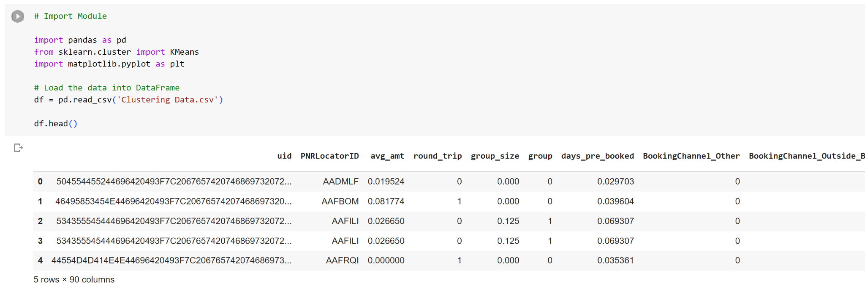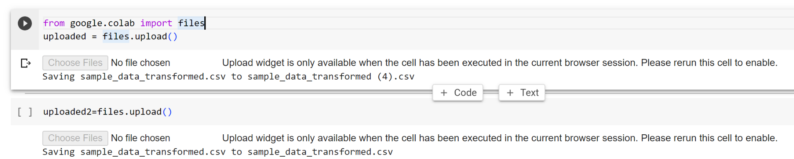

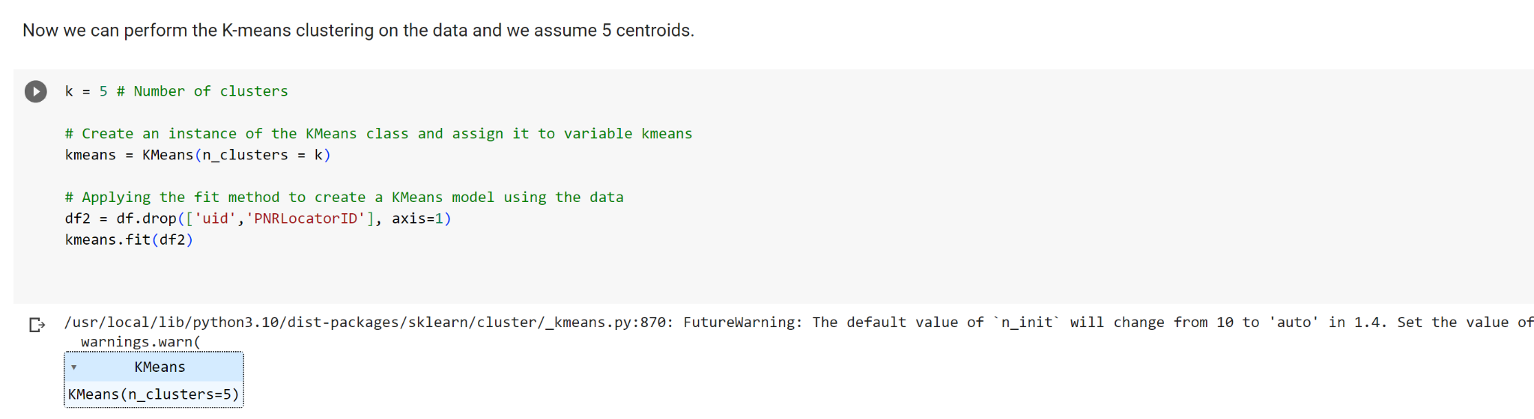



### Step 2: Now we extract the cluster "Assignments" from the cluster results data set and add it to the reservations data.

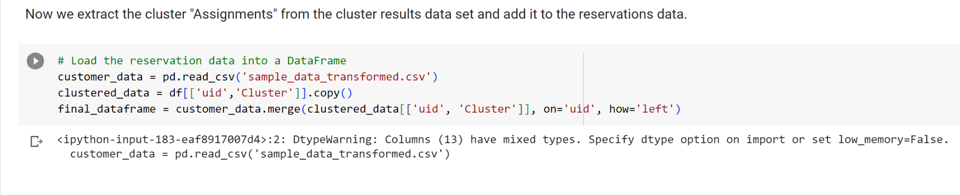

### Step 3: Now we are trying to visualize the segment data by using Python.

